This document gives complete design information of PCC_Rev-C board.

The PCC board is responsible for powering the NGP system. It receives dual 24V (range from 18V to 32V) supplies on board. The dual supplies need to be hot swapped and ORed on board. The hot swapped and ORed 24V supply needs to be filtered. The Filtered 24V needs to power IOP boards and generate 6.5V supply to power all boards in the system. The Power requirement of the IOP supply is 24V @8A, the same on 6.5V is 6.5V @25A.

Front panel LED’s description:
There are 4 front panel LEDs as mentioned below.

Alarm LED: A yellow LED placed on the front panel of the PCC boards indicates that the board is functional yet there is something wrong going on, on the PCCs. The alarm is LED is driven by 24V_F_internal supply and by firmware using 2 signals named Alarm_IES_A and Alarm_IES_B. MPC5534 processors on IES’s monitors PCC’s power good signals of DC-DC converters, temperature, load power and does a math to generate alarm signals which reach PCCs via I/O expander chips. The alarm signals are active high, hence by default they are active low signals. Circuit is shown below.

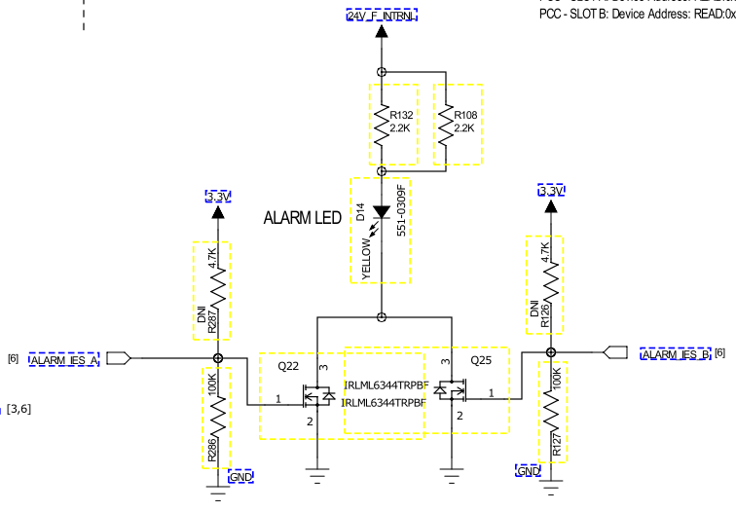

Fault LED: A red LED placed on the front panel of the PCC boards indicates that the board is fault on the PCC. The fault is LED is driven by 24V_F_internal supply, 2 hardware power good signals (6.5V_A, 6.5V_B, F_24V) and by firmware using 2 signals named Fault_IES_A and Fault_IES_B. MPC5534 processors on IES’s monitors PCC’s power good signals of DC-DC converters, temperature, load power and does a math to generate fault signals which reach PCCs via I/O expander chips. The fault signals are active high, hence by default they are active low signals. Circuit is shown below.

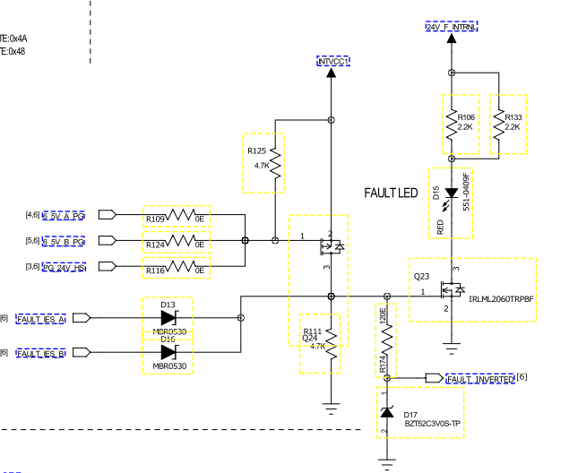

24V-A LED: A green LED on the front panel to indicate presence of 24V-A supply on PCC.

24V-B LED: A green LED on the front panel to indicate presence of 24V-B supply on PCC.

2 White LEDs: There are two white LEDs placed on up and down side of the board in order to help the servicemen see.

I2C devices Addresses for I2C bus from IES-A:

Ref. Des. | MFG P/N | Address | Address(Hex)
U3 | LTC4151HMS#PBF | SLOT-A | 0xD2
 |  | SLOT-B | 0xCE
U13 | ADT7410TRZ | SLOT-A | 0x4B
 |  | SLOT-B | 0x4A
U16 | PCA9555BS,118 | SLOT-A
 |  | READ | 0x4F
 |  | WRITE | 0x4E
 |  | SLOT-B
 |  | READ | 0X4D
 |  | WRITE | 0x4C
U26 | AT24C01BN-SH-B | SLOT-A
 |  | READ | 0xA3
 |  | WRITE | 0xA2
 |  | SLOT-B
 |  | READ | 0xA1
 |  | WRITE | 0xA0

I2C devices Addresses for I2C bus from IES-B:
Ref. Des. | MFG P/N | Address | Address(Hex)
U1 | LTC4151HMS#PBF | SLOT-A | 0xD2
 |  | SLOT-B | 0xCE
U23 | ADT7410TRZ | SLOT-A | 0x4B
 |  | SLOT-B | 0x4A
U10 | PCA9555BS,118 | SLOT-A
 |  | READ | 0x4F
 |  | WRITE | 0x4E
 |  | SLOT-B
 |  | READ | 0X4D
 |  | WRITE | 0x4C
U12 | AT24C01BN-SH-B | SLOT-A
 |  | READ | 0xA3
 |  | WRITE | 0xA2
 |  | SLOT-B
 |  | READ | 0xA1
 |  | WRITE | 0xA0

I/O signal description: Below shown is the power connector with signal assignment. 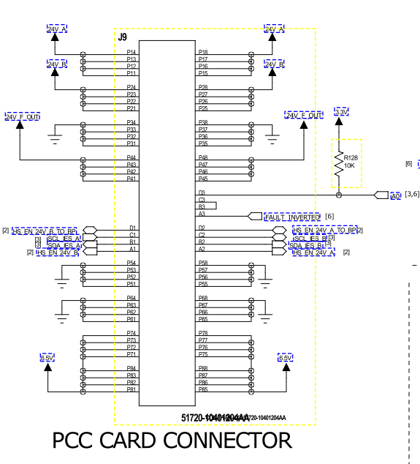
Power Pins:

24V_A: 24V_A DC supply input to PCC
24V_B: 24V_B DC supply input to PCC
24V_F_OUT: 24V filtered and reverse polarity protected DC supply output from PCC to IOPs
6.5V: 6.5V DC supply out to all boards in NGP from PCC

Signal Pins:
HS_EN_24V_A_TO_BP: 24V supply enable signal for 24V_A supply hot swap that goes to back plane and comes back on another pin(HS_EN_24V_A) to make sure PCC is PCC is inserted properly and then enabling hot swap. These two signals will be shorted on backplane.

HS_EN_24V_B_TO_BP: 24V supply enable signal for 24V_A supply hot swap that goes to back plane and comes back on another pin(HS_EN_24V_B) to make sure PCC is PCC is inserted properly and then enabling hot swap. These two signals will be shorted on backplane.

SCL_IES_A, SDA_IES_A: I2C bus that comes from IES-A board processor
SCL_IES_B, SDA_IES_B: I2C bus that comes from IES-B board processor

FAULT_INVERETD: An inverted fault LED status input to IES A and B. This is useful if the I2C interfaces on IES A&B are not functional.

A0: This signal enables Processors on IES to differentiate PCCs by differently configuring LSB of all I2C devices on both PCC slots. The I2C devices of PCC card inserted in PCC slot A will have a different set of addresses compared to the one inserted in slot-B

I2C I/O expanders: There are two I2C I/O expander chips on PCC that help increase I/Os that can communicate to both IES. A PCC should communicate to both IES simultaneously, hence two I/O expanders. The I/Os are bidirectional.

LDO for 3.3V Rail
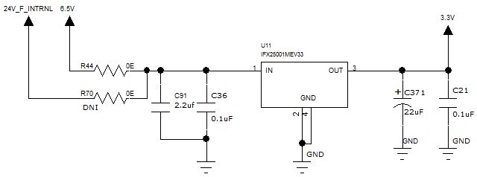

Over Voltage protection for 24V rail
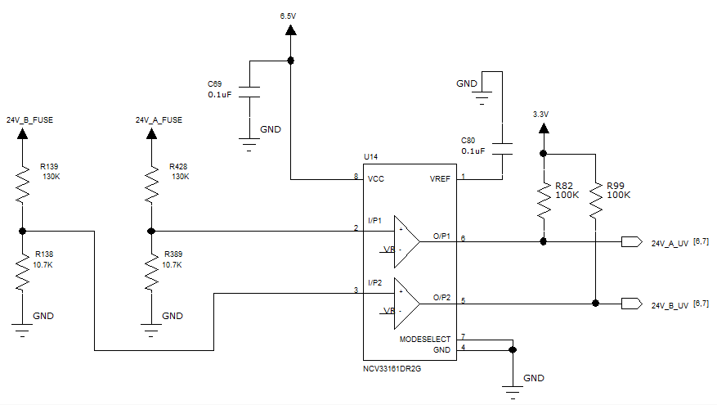
Fault and Over Voltage Detection LED's using AND Circuit
